


Internal Controls Who is Watching?

Jim Royse, Executive Director February 19, 2025


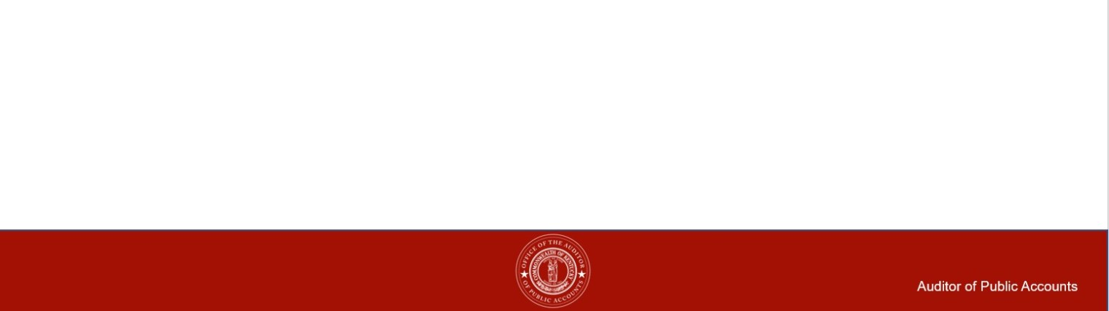
Agenda

• Internal Controls

• Internal Control Checkup • Top 10 Internal Controls • 2025 AUP Volunteers

Internal Controls

• Good internal controls are good business

• Organizations manage risk by balancing risks and controls

• Everyone in the organization has responsibility for internal control

• Good Internal Controls start with an organizational structure and philosophy which nurtures and rewards integrity, ethical behavior and competence

Why are internal controls important?

Internal controls reduce the likelihood of fraud or errors and provide for:
• Accountability
• Efficient and effective operations • Reliable management reporting
• Compliance with laws and regulations
• Protection of assets including organizational reputation


Takeaways From Video

• Proper Tone at the Top

• Controls are Absent – “Free Money”

• Good Controls in Place – The eyes are watching

Tone At The Top

“Effective leaders strive to surround themselves with competent people, instill an enterprise-wide attitude of integrity and control consciousness, and set a positive 'tone at the top”

(Dennis Dycus, CFE, CPA, CGFM, Association of Certified Fraud Examiners)

Tone At The Top

• It all Starts With You as the Official

• Officials set the moral and ethical compass for all others to follow

• Officials must communicate a zero tolerance for fraud and reinforce the message daily – Both in Words and Actions

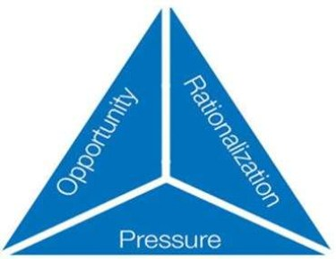
Controls are Absent

• Creates Opportunity • Fraud Triangle:
• Three Conditions Generally Present When Fraud Occurs:
➢ Rationalization/Attitude ➢ Pressure (Need)
➢ Opportunity

Rationalization/Attitude –

• An attitude, character, or set of ethical values that allow an
individual to justify committing a dishonest act.

▪“I work harder than anyone here, I deserve this.”
▪“She makes more than me and I work just as hard or harder
and I deserve this”
▪“What is going on is my life is unfair, this little extra will help
me out and they will never miss it.” ▪“I see them doing it, so I will too.”

Incentive/Pressure

• Management or other employees may have incentive or be
under pressure to commit fraud
▪Loss of Family Members Employment ▪Divorce
▪Personal Financial Problems/Bankruptcy ▪Medical Condition
▪Drug/Substance Abuse ▪Gambling Addiction
▪Living Beyond Their Means

Opportunity

• Circumstances provide an opportunity for fraud to be committed

Opportunity/Factors Contributing to Fraud

• Lack of Internal Controls

• Lack of Employees Fraud Education

• Lack of Reporting Mechanism

• Lack of Segregation of Duties

• Blind Trust

• Cash not Deposited Daily

2010 Report to the Nations on Occupational Fraud and Abuse , published by the Association of Certified Fraud Examiners

Impacts of Fraud

• Government Outcomes Impact • Reputational Impact
• Financial Impact • Business Impact

What can you do?

• You can only Control the Opportunity

• By implementing a strong internal control system, officials remove the opportunity!

Internal Control Checkup

1. Establish a Control Environment 2. Conduct Risk Assessment
3. Implement Control Activities

4. Implement Information and Communication System 5. Monitor Internal Controls

Control Environment

• The oversight body and management should demonstrate a commitment to integrity and ethical values.

• The oversight body should oversee the entity’s internal control system.

• Management should establish an organizational structure, assign responsibility and delegate authority to achieve the entity’s objectives.

• Management should demonstrate a commitment to recruit, develop and retain competent individuals.

• Management should evaluate performance and hold individuals accountable for their internal control responsibilities.

SOI: GAO

Risk Assessment

• Management should define objectives clearly to enable the identification of risks and define risk tolerances.

• Management should identify, analyze, and respond to risks related to achieving the defined objectives.

• Management should consider the potential for fraud when identifying, analyzing and responding to risks.

• Management should identify, analyze and respond to significant changes that could impact the internal control system.

Control Activities

• Management should design control activities to achieve objectives and respond to risks.

• Management should design the entity’s information system and related control activities to achieve objectives and respond to risks.

• Management should implement control activities through policies.

Information & Communication

• Management should use quality information to achieve the entity’s objectives.

• Management should internally communicate the necessary quality information to achieve the entity’s objectives.

• Management should externally communicate the necessary quality information to achieve the entity’s objectives.

Monitoring

• Management should establish and operate a monitoring mechanism that monitors both internal and external activities that impact the control system and evaluate the results.

• Management should remediate identified internal control deficiencies on a timely basis.

Top 10 Governmental Internal Controls

1. Segregation of Duties

2. Documentation

3. Authorization and Approval

4. Security of Assets

5. Reconciliation and Review
6. Policies and Procedures

7. Fraud Policy and Reporting

8. Access to Systems

9. Physical Control

10. Verification (pre-employment)

Segregation Of Duties

The concept that no single individual in an organization has control over two or more phases of a transaction.

It is used to ensure not only intentional fraud, but also innocent error, are prevented or detected on a timely basis.

Segregation Of Duties

Four general functions that should be segregated: • Authorization/Approval
• Custody
• Record keeping/Reporting • Reconciliation

We know that some small offices cannot have proper segregation of duties.

Segregation Of Duties

You can implement compensating controls to help offset this lack of segregation of duties

Compensating Controls are internal controls that reduces the risk of an existing or potential control weakness resulting in errors and omissions.

Compensating Controls Examples

You or Someone independent of the process checking source documentation and comparing the amounts to the appropriate records and reports
• Trace daily checkout to bank deposit and Ledger • Trace check to invoice and Ledger
• Perform Surprise Cash Counts • Dual Signature on Checks
These should all be documented to prove the compensating controls exist and were performed

Oversight –Authorization and Approval

Ask the right questions!
If the answer is “Because we always did it this way,” then YOU
NEED to ask WHY?
• Find out:
• What are the requirements? • Is it being done correctly?

As the Elected Official you are responsible for everything that happens in your office and for all the funds that flow through your
office


Reconciliation and Review

Reconcile bank accounts every month.
1.Require the reconciliation to be completed by an independent person who doesn’t have bookkeeping responsibilities or check signing responsibilities or require supervisory review of the reconciliation.
2.Examine canceled checks to make sure vendors are recognized, expenditures are related to agency business, signatures are by authorized signers, and endorsements are appropriate.
3.Examine bank statements and cancelled checks to make sure checks are not issued out of sequence.
4.Initial and date the bank statements or reconciliation report to document that a review and reconciliation was performed and file the bank statements and reconciliations.

Policies and Procedures

Prepare all fiscal policies and procedures in writing. Examples are policies and procedures on the following
functions:
1. Cash Disbursements 2. Attendance and Leave
3. Expense and Travel Reimbursements 4. Use of Agency Assets
5. Purchasing Guidelines 6. Petty Cash
7. Conflicts of Interest

Access to Systems
Information Technology Control

• Passwords
• Should be strong, not something someone could guess • Not written down
• Not shared
• Changed Regularly

• Data should be backed-up

• Anti-virus software should be up to date and working

Conclusion

Key Takeaways:

• Internal controls are the mechanisms, rules, and procedures implemented by a you to ensure the integrity of financial and accounting information, promote accountability and prevent fraud.


2025 AUP
Volunteers

This Photo by Unknown Author is licensed under CC BY-SA-NC

Questions?

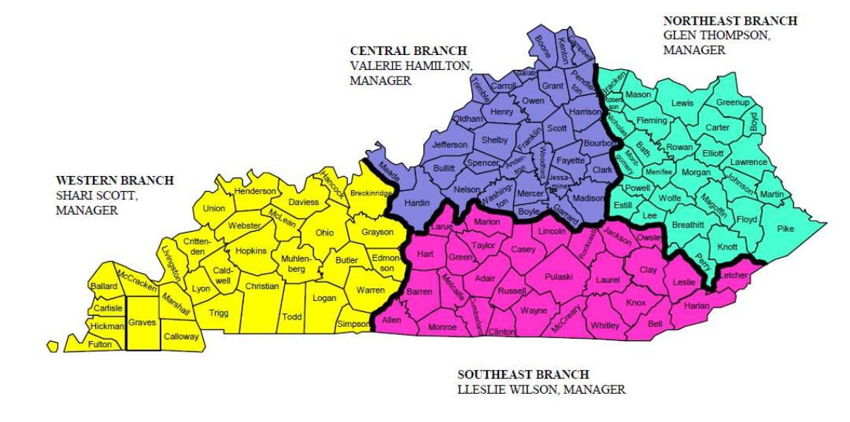
APA Local Government Audit Branches

Contact Information:

Auditor of Public Account Office • (502) 564-5841
Northeast Branch – Glen Thompson
• Ext. 2919 glen.thompson@ky.gov
Central Branch – Valerie Hamilton
• Ext. 2862 valerie.hamilton@ky.gov
Western Branch – Shari Scott
• Ext. 2881 shari.scott@ky.gov
Southeastern Branch – Lleslie Wilson • Ext. 2886 lleslie.wilson@ky.gov

Contact Information:

Quality Assurance Branch Manager – Liz Lowe • Ext. 2926 Liz.Lowe@ky.gov
Executive Director – Jim Royse
• Ext. 2924 James.Royse@ky.gov

Deputy State Auditor – Shawnna Crouse • Ext. 2902 Shawnna.Crouse@ky.gov

